Procedures:
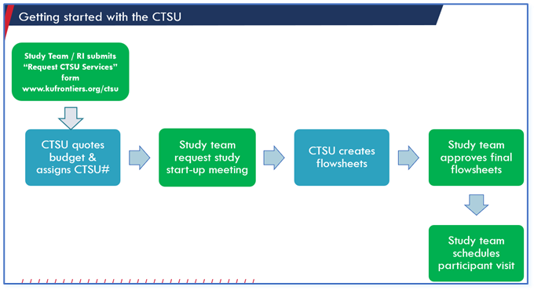
- Submit the “Clinical Research Start Up Form.” https://redcap.kumc.edu/surveys/?s=KFJYK87MAJ
  - This is in combination with the Research Institute (RI) Redcap form. This informs the RI that you will need CTSU services. This will help with budget finalization as the CTSU fees can be included within your study budget for negotiations.
    - The study does not have to be IRB approved to complete the CTSU request for services; however, final approval must be received prior to seeing study participants.
    - If possible, all documents required for study start up (most up to date protocol, lab manual, and pharmacy manual) should be included in this request. This will allow the CTSU to provide a more accurate quote.
- CTSU Setup:
  - Once CTSU receives the Request for Services, the following items will be completed:
    - A CTSU protocol number will be assigned.
    - A draft CTSU budget quote will be provided to the requestor.

- Study Start Up Meeting With the CTSU
  - A start up meeting must happen before seeing the first participant in the CTSU.
  - CTSU Rainbow: You will need to send a meeting request to Shelby Williams, CTSU Rainbow Director, for the date and time that best fits your schedule and availability.
  - CTSU Fairway: You will send a meeting request to Jackie Burditt for the date and time that best fits your schedule and availability.
  - Study startup needs to be scheduled a minimum of 2 weeks but no more than 2 months prior to seeing the first participant.
  - Startup can be done by video, in person, or email depending on complexity of the protocol.
    - If the study is using “space only” then a study start up can take place via email.
  - Items needed 1 week prior to the study start up meeting:
    - Study billing number
    - IRB approval letter (from KUMC)
    - Most recent & approved protocol & consent(s)
    - Lab manual/lab processing information (if applicable)
    - Pharmacy manual (if applicable)
    - MOP/MOO (if applicable
  - CTSU will be happy to meet more often as needed during protocol planning, but this does not substitute for the study startup.

- Post Study Start Up Meeting
  - The CTSU will create source documents / flowsheets for the CTSU specific tasks once all required information is received from Study Team.
    - Once completed, these are sent to the study team for review and approval.
      - If the study team does not respond within 1 week by the time the first participant is scheduled, these will be placed into circulation unless requested otherwise.
      - It is critical that the study team thoroughly review these to ensure the order of procedures are accurate and all tasks are accounted for.
    - If there are flowsheet revisions:
      - Please email swilliams46@kumc.edu for CTSU Rainbow flowsheet revisions, and jburditt@kumc.edu for CTSU Fairway flowsheet revisions.
      - Once completed, the revised version will be sent to the study team for approval.
      - Turnaround time for revisions should not exceed 1 week unless otherwise arranged with the study team
  - A “new study email’ is sent to all CTSU staff
    - This email will include all pertinent study documents that must be reviewed by CTSU
    - This email confirms to the CTSU staff that study appointments may be accepted.

- Schedule your participant via Outlook Calendar New Meeting
  - CTSU Rainbow: ctsurainbow@kumc.edu
  - For CTSU Rainbow Pulmonology Testing Services: add CTSUPulm@kumc.edu
  - CTSU Fairway: ctsufairway@kumc.edu
  - “Title” should include:
    - CTSU#
    - Study Visit #
    - Participants initials
  - “Location” (whichever is applicable):
    - CTSU Fairway
    - CTSU Rainbow Sudler
    - CTSU Rainbow Delp
  - Select the start time and end time
  - Included in the body of the appointment:
    - Participants full name
    - Anticipated schedule of events needing CTSU support
    - If necessary, a specific room can be requested.
    - Please list in the appointment if there will be any protocol deviations (i.e., no ECG today, biopsy to be completed at next visit, etc.)

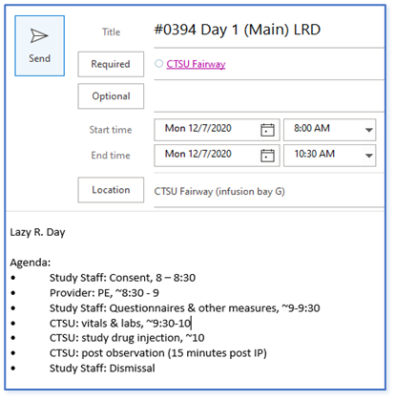

  - Your appointment request is NOT confirmed until you have received an email from CTSU.
  - For URGENT or last-minute requests/changes you must advise the CTSU:
    - CTSU Fairway: call 913-588-0972
    - CTSU Rainbow: call 913-574-3007
  - Appointment times are firm
    - Changes to the appointment time must be approved by the CTSU. This should be PRIOR to confirming the change with the participant.
    - If the participant arrives late for the visit or if the CTSU was not notified of the appointment, the CTSU reserves the right to request a reschedule.
- Your study participants arrival
  - Must check in with the CTSU
  - If the participant is new to the CTSU, ensure they fill out a ‘CTSU Registration’ form and return to CTSU staff
  - BEFORE study procedures start, ensure a signed copy of the most current consent is collected and a copy is given to the CTSU staff
  - Upon completion of the visit, sign the participant out with the CTSU
Additional Information:
- Delegation of Duties and Training
  - CTSU staff should NOT be listed on a delegation log, 1572, or as Clinical Trial Staff on research protocols
  - CTSU administration may approve additional training for CTSU staff for study procedures that are not considered routine practice. This will be decided on a case-by-case basis
  - CTSU administration can also approve addition of CTSU staff as Clinical Trial staff to a delegation log for sponsors who require it
  - All CTSU staff must be included in this training
    - Training will be billed @ $75.00/hour, per person, with a minimum charge of 1 hour in a single setting
    - After the initial hour billing will be in 15-minute increments
  - This request can be made to swilliams46@kumc.edu for CTSU Rainbow, and lmussulman@kumc.edu for CTSU Fairway
- Any time the study team asks CTSU to go outside of regularly planned protocol procedures, communication from sponsor must be provided to the CTSU to justify the deviation from the protocol.
- CTSU does not provide study specific supplies
  - Upon request, CTSU can assist in ordering study supplies
  - All costs associated with ordering study supplies will be interdepartmental billed to the study at time of purchase
  - CTSU does not inventory or monitor study supplies for adequate stock or expiration dates
  - CTSU leadership must provide approval before study teams can store supplies or equipment in the CTSU.
- To sched a tour of the CTSU:
  - CTSU Rainbow: send an outlook appointment to swilliams46@kumc.edu
  - CTSU Fairway: send an Outlook appointment to lmussulman@kumc.edu
- Study Visits with Labs:
  - All study materials are purchased and provided by the study team.
  - All lab kits should be assembled by the study team, verified for accuracy, QC’d and delivered to the CTSU no later than 2pm the working day prior to the scheduled appointment.
  - All requisitions should be filled out prior to dropping off the lab kits
  - Ensure the CTSU flowsheet, the protocol schedule of events, and the lab manual match the kit
    - Discrepancies should be corrected by the study team. Please contact the study coordinator if a lab kit is missing items or is labeled incorrectly.
    - Floe flow sheet discrepancies, please email the proper team listed below before 2 pm the workday prior to the scheduled visit:
      - CTSU Rainbow: email mwright15@kumc.edu and swilliams46@kumc.edu
      - CTSU Fairway: email edelaney2@kumc.edu and jburditt@kumc.edu
    - Study Team is responsible for packing and shipping labs to the study’s central lab
      - CTSU can be hired to perform the task if the study requests
    - CTSU only provides short-term sample storage on site
    - KU (TUKHS) Labs
      - Orders must be placed EPIC by the study team in advance of the study visit
      - CTSU Fairway Location:
        - CTSU Staff will send the labs to the 1st Floor KU Lab in the CRC via a pneumatic tube
        - KU Lab will provide CTSU Fairway with the correct blood collection tubes
        - CTSU will provide labeling for KU Labs only
      - CTSU Rainbow Location:
        - Study Team is responsible for delivery of the KU Labs to a KU lab location
        - KU Lab will provide study teams with correct blood collection tubes specifically for KU labs
        - The study team must provide the labeled collection tubes to CTSU staff
          - Label must have name and medical record number

Study Team Must:
- Study Team should arrive at least 5 minutes early to receive their scheduled participant.
  - The study team Is responsible for ensuring their participant has arrived
- Conduct COVID-19 screening
- Provide a CTSU Registration form for new participants
- Provide a completed signed order by the Investigator for subjects requiring medication administration
- Provide the most current HSC approved protocol, study documents, and signed ICF throughout the study
- Ensure participant visits are scheduled and approved by the CTSU in advance
  - All CTSU delegated study procedures including lab processing and storage must occur between our normal business hours, M – F, 7:30 a.m. and 4:30 p.m.
  - All visits scheduled outside of CTSU hours requires leadership approval and must be submitted no less than two weeks in advance.

APPROVED BY:

CTSU Fairway Scientific Director, Dr. Jeff Burns:

CTSU Fairway Administrative Director, Laura Mussulman:

Origination: 01.19.2022
Last Approved: 05.06.2022
Last Revised: 05.06.2022

